**TUGAS PRAKTIKUM**

**PRAKTIKUM PAW**

**MODUL 7 “Laravel CRUD”**



|  |
| --- |
| **Disusun Oleh:**  Nama: Fikri Ainun Najib  NIM:200411100153  Kelas: PAW B  **Dosen Pengampu:**  Nama: Ach. Khozaimi, S.Kom., M.Kom  NIP: 19860926 201404 1 001  **Asisten Praktikum:**  Nama: Alief Fadhilah Athallariq  NIM: 180411100028 |

**PRODI TEKNIK INFORMATIKA**

**JURUSAN TEKNIK INFORMATIKA  
FAKULTAS TEKNIK**

**UNIVERSITAS TRUNOJOYO MADURA**

**2022**

1. **Soal:** Melihat semua Mahasiswa

**Source Code menampilkan:**

|  |
| --- |
| @extends('layouts.tamplate', ['title' => 'Tampil Data', 'home' => 'active'])  @section('content')  <div class="row justify-content-center">  <!-- Earnings (Monthly) Card Example -->  <div class="col-11">  <h1>Tampil Data</h1>  <a href="/tambah" class="btn btn-primary mb-1">Tambah Data</a>  <div class="container justify-content-center text-center">  <!-- DataTales Example -->  <div class="card shadow mb-4">  <div class="card-header py-3">  <h6 class="m-0 font-weight-bold text-primary">Data Mahasiswa</h6>  </div>  <div class="card-body">  <div class="table-responsive">  <table class="table table-bordered" id="dataTable" width="100%" cellspacing="0">  <thead>  <tr>  <th>NIM</th>  <th>NAMA</th>  <th>UMUR</th>  <th>ALAMAT</th>  <th>AKSI</th>  </tr>  </thead>  <tbody>  {{-- jika tidak ada data --}}  @if ($mahasiswa->isEmpty())  <tr>  <td colspan="5" class="text-center">Data Kosong</td>  </tr>  @endif  @foreach ($mahasiswa as $siswa)  <tr>  <td>{{ $siswa->nim }}</td>  <td>{{ $siswa->nama }}</td>  <td>{{ $siswa->umur }}</td>  <td>{{ $siswa->alamat }}</td>  <td>  <a href="/nilai/{{ $siswa->nim }}" class="btn btn-info">Beri Nilai</a>  <a href="/edit/{{ $siswa->nim }}" class="btn btn-warning">Edit</a>  <form action="/hapus/{{ $siswa->nim }}" method="POST">  @csrf  <button class="btn btn-danger m-1"  onclick="return confirm('yakin?')">Hapus</button>  </form>  {{-- <a href="/hapus/{{ $siswa->nim }}" class="btn btn-danger">Hapus</a> --}}  </tr>  @endforeach  </tbody>  </table>  </div>  </div>  </div>  </div>  </div>  </div>  @endsection |

**Screenshoot:**

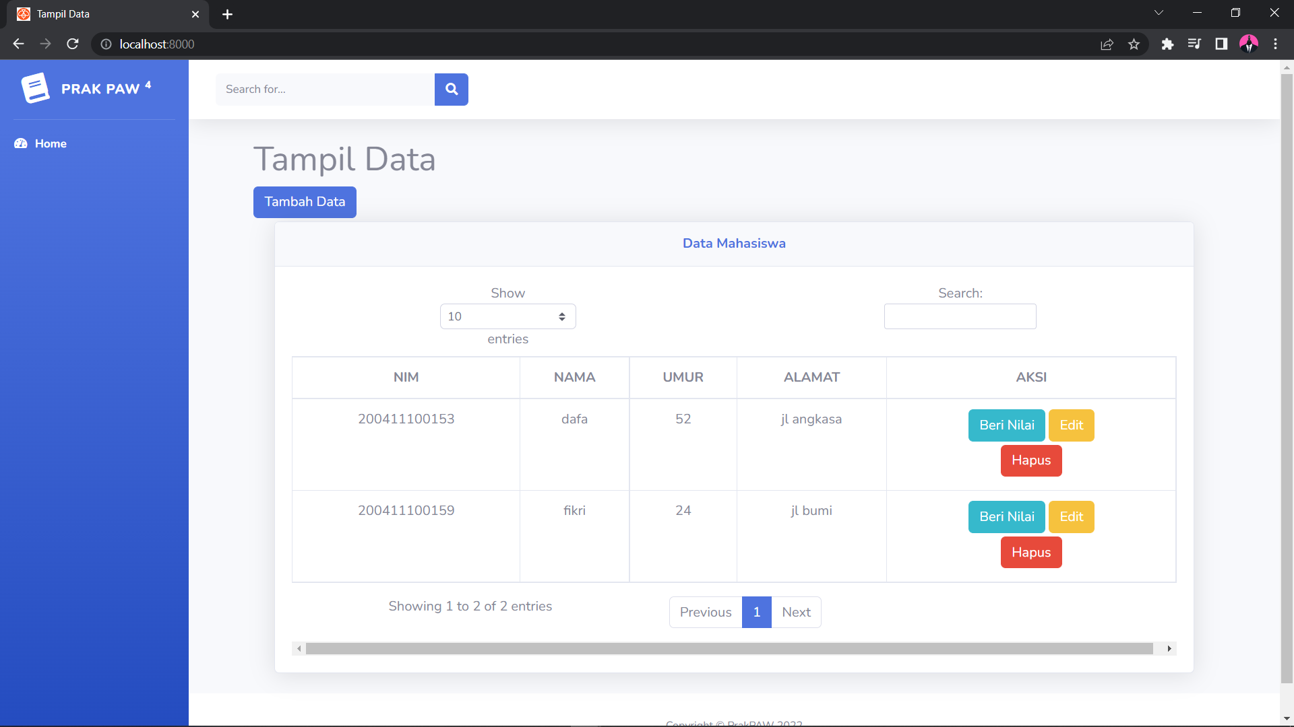

1. **SOAL :** - Melihat mahasiswa berdasarkan NIM

**Source Code menambahkan:**

|  |
| --- |
| /*! DataTables Bootstrap 4 integration  * ©2011-2017 SpryMedia Ltd - datatables.net/license  */  /**  * DataTables integration for Bootstrap 4. This requires Bootstrap 4 and  * DataTables 1.10 or newer.  *  * This file sets the defaults and adds options to DataTables to style its  * controls using Bootstrap. See http://datatables.net/manual/styling/bootstrap  * for further information.  */  (function( factory ){  if ( typeof define === 'function' && define.amd ) {  // AMD  define( ['jquery', 'datatables.net'], function ( $ ) {  return factory( $, window, document );  } );  }  else if ( typeof exports === 'object' ) {  // CommonJS  module.exports = function (root, $) {  if ( ! root ) {  root = window;  }  if ( ! $ || ! $.fn.dataTable ) {  // Require DataTables, which attaches to jQuery, including  // jQuery if needed and have a $ property so we can access the  // jQuery object that is used  $ = require('datatables.net')(root, $).$;  }  return factory( $, root, root.document );  };  }  else {  // Browser  factory( jQuery, window, document );  }  }(function( $, window, document, undefined ) {  'use strict';  var DataTable = $.fn.dataTable;  /* Set the defaults for DataTables initialisation */  $.extend( true, DataTable.defaults, {  dom:  "<'row'<'col-sm-12 col-md-6'l><'col-sm-12 col-md-6'f>>" +  "<'row'<'col-sm-12'tr>>" +  "<'row'<'col-sm-12 col-md-5'i><'col-sm-12 col-md-7'p>>",  renderer: 'bootstrap'  } );  /* Default class modification */  $.extend( DataTable.ext.classes, {  sWrapper: "dataTables_wrapper dt-bootstrap4",  sFilterInput: "form-control form-control-sm",  sLengthSelect: "custom-select custom-select-sm form-control form-control-sm",  sProcessing: "dataTables_processing card",  sPageButton: "paginate_button page-item"  } );  /* Bootstrap paging button renderer */  DataTable.ext.renderer.pageButton.bootstrap = function ( settings, host, idx, buttons, page, pages ) {  var api = new DataTable.Api( settings );  var classes = settings.oClasses;  var lang = settings.oLanguage.oPaginate;  var aria = settings.oLanguage.oAria.paginate || {};  var btnDisplay, btnClass, counter=0;  var attach = function( container, buttons ) {  var i, ien, node, button;  var clickHandler = function ( e ) {  e.preventDefault();  if ( !$(e.currentTarget).hasClass('disabled') && api.page() != e.data.action ) {  api.page( e.data.action ).draw( 'page' );  }  };  for ( i=0, ien=buttons.length ; i<ien ; i++ ) {  button = buttons[i];  if ( Array.isArray( button ) ) {  attach( container, button );  }  else {  btnDisplay = '';  btnClass = '';  switch ( button ) {  case 'ellipsis':  btnDisplay = '&#x2026;';  btnClass = 'disabled';  break;  case 'first':  btnDisplay = lang.sFirst;  btnClass = button + (page > 0 ?  '' : ' disabled');  break;  case 'previous':  btnDisplay = lang.sPrevious;  btnClass = button + (page > 0 ?  '' : ' disabled');  break;  case 'next':  btnDisplay = lang.sNext;  btnClass = button + (page < pages-1 ?  '' : ' disabled');  break;  case 'last':  btnDisplay = lang.sLast;  btnClass = button + (page < pages-1 ?  '' : ' disabled');  break;  default:  btnDisplay = button + 1;  btnClass = page === button ?  'active' : '';  break;  }  if ( btnDisplay ) {  node = $('<li>', {  'class': classes.sPageButton+' '+btnClass,  'id': idx === 0 && typeof button === 'string' ?  settings.sTableId +'_'+ button :  null  } )  .append( $('<a>', {  'href': '#',  'aria-controls': settings.sTableId,  'aria-label': aria[ button ],  'data-dt-idx': counter,  'tabindex': settings.iTabIndex,  'class': 'page-link'  } )  .html( btnDisplay )  )  .appendTo( container );  settings.oApi._fnBindAction(  node, {action: button}, clickHandler  );  counter++;  }  }  }  };  // IE9 throws an 'unknown error' if document.activeElement is used  // inside an iframe or frame.  var activeEl;  try {  // Because this approach is destroying and recreating the paging  // elements, focus is lost on the select button which is bad for  // accessibility. So we want to restore focus once the draw has  // completed  activeEl = $(host).find(document.activeElement).data('dt-idx');  }  catch (e) {}  attach(  $(host).empty().html('<ul class="pagination"/>').children('ul'),  buttons  );  if ( activeEl !== undefined ) {  $(host).find( '[data-dt-idx='+activeEl+']' ).trigger('focus');  }  };  return DataTable;  })); |

**Screenshot :**

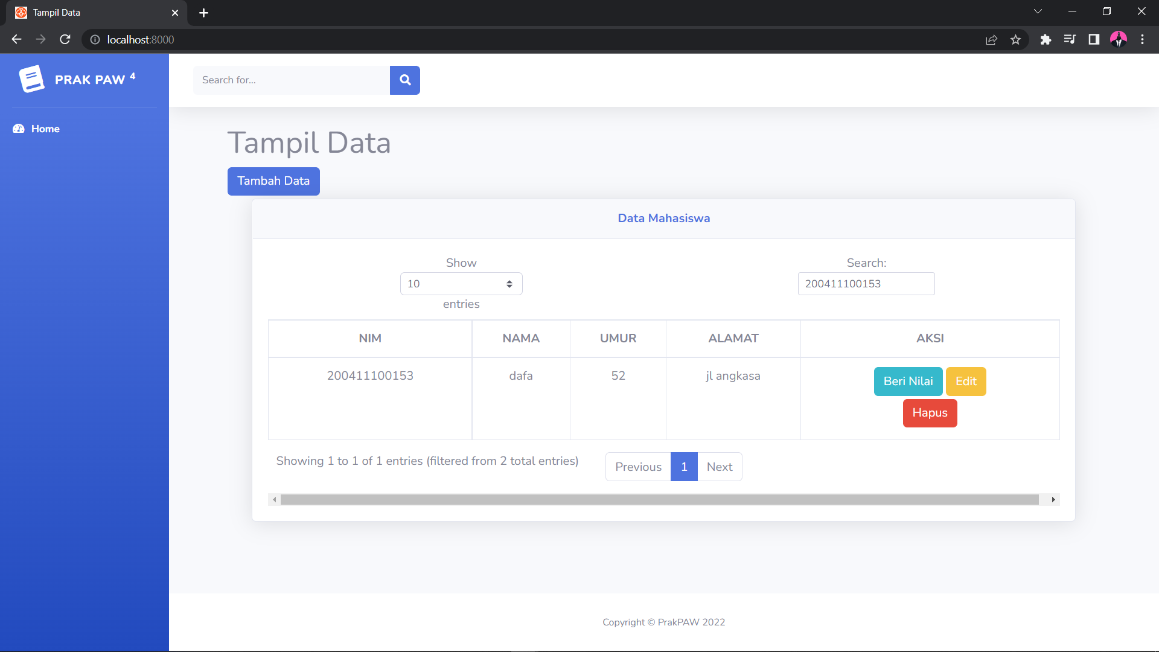

1. **SOAL :** - Mengupdate data Mahasiswa

**Source Code mengupdate:**

|  |
| --- |
| @extends('layouts.tamplate', ['title' => 'Edit Data'])  @section('content')  <div class="row justify-content-center">  <!-- Earnings (Monthly) Card Example -->  <div class="col-11">  <div class="container justify-content-center text-center">  <h1>Edit Data</h1>  <form action="/prosesedit" method="POST">  @csrf  <input type="hidden" class="form-control" value="{{ $mahasiswa->nim }}" name="nimold" required>  <div class="form-group">  <label for="nim">NIM</label>  <input type="text" class="form-control" id="nim" value="{{ $mahasiswa->nim }}"  placeholder="Masukkan NIM" name="nim" required>  </div>  <div class="form-group">  <label for="nama">Nama</label>  <input type="text" class="form-control" id="nama" value="{{ $mahasiswa->nama }}"  placeholder="Masukkan Nama" name="nama" required>  </div>  <div class="form-group">  <label for="umur">Umur</label>  <input type="number" class="form-control" id="umur" value="{{ $mahasiswa->umur }}"  placeholder="Masukkan Umur" name="umur" required>  </div>  <div class="form-group">  <label for="alamat">Alamat</label>  <input type="text" class="form-control" id="alamat" value="{{ $mahasiswa->alamat }}"  placeholder="Masukkan Alamat" name="alamat" required>  </div>  <button type="submit" class="btn btn-primary">Submit</button>  </form>  </div>  </div>  </div>  @endsection |

**Screenshot :**

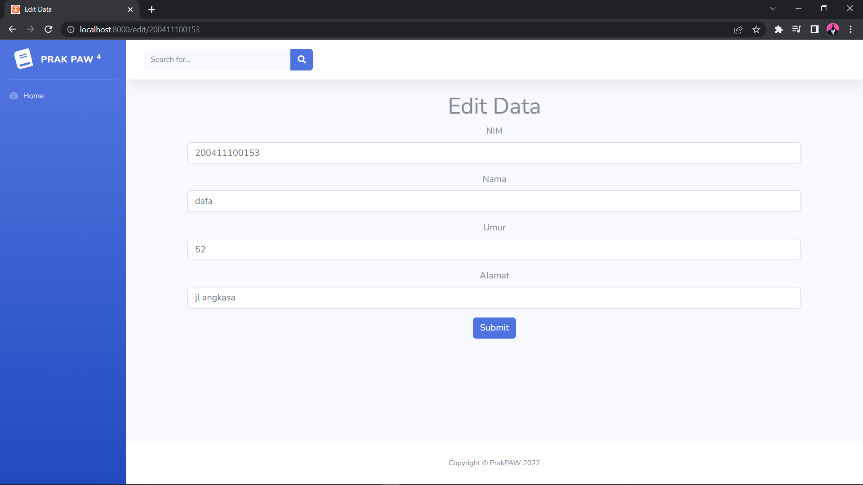

1. **SOAL :** - Menambah Nilai Mahasiswa (1 page berbeda dari update mahasiswa, karena khusus update untuk kolom nilai saja)

**Source Code proses menambahkan nilai:**

|  |
| --- |
| @extends('layouts.tamplate', ['title' => 'Beri Nilai'])  @section('content')  <div class="row justify-content-center">  <!-- Earnings (Monthly) Card Example -->  <div class="col-11">  <div class="container justify-content-center text-center">  <h1>Beri Nilai</h1>  <form action="/prosesnilai" method="POST">  @csrf  <div class="form-group">  <label for="nilai">Nilai</label>  <input type="number" class="form-control" id="nilai" min="1" max="100"  value="{{ $mahasiswa->nilai }}" placeholder="Masukkan Nilai" name="nilai" required>  </div>  <div class="form-group">  <label for="nim">NIM</label>  <input type="text" class="form-control" id="nim" value="{{ $mahasiswa->nim }}"  placeholder="Masukkan NIM" name="nim" required readonly>  </div>  <div class="form-group">  <label for="nama">Nama</label>  <input type="text" class="form-control" id="nama" value="{{ $mahasiswa->nama }}"  placeholder="Masukkan Nama" name="nama" required readonly>  </div>  <div class="form-group">  <label for="umur">Umur</label>  <input type="number" class="form-control" id="umur" value="{{ $mahasiswa->umur }}"  placeholder="Masukkan Umur" name="umur" required readonly>  </div>  <div class="form-group">  <label for="alamat">Alamat</label>  <input type="text" class="form-control" id="alamat" value="{{ $mahasiswa->alamat }}"  placeholder="Masukkan Alamat" name="alamat" required readonly>  </div>  <button type="submit" class="btn btn-primary">Submit</button>  </form>  </div>  </div>  </div>  @endsection |

**SS :**

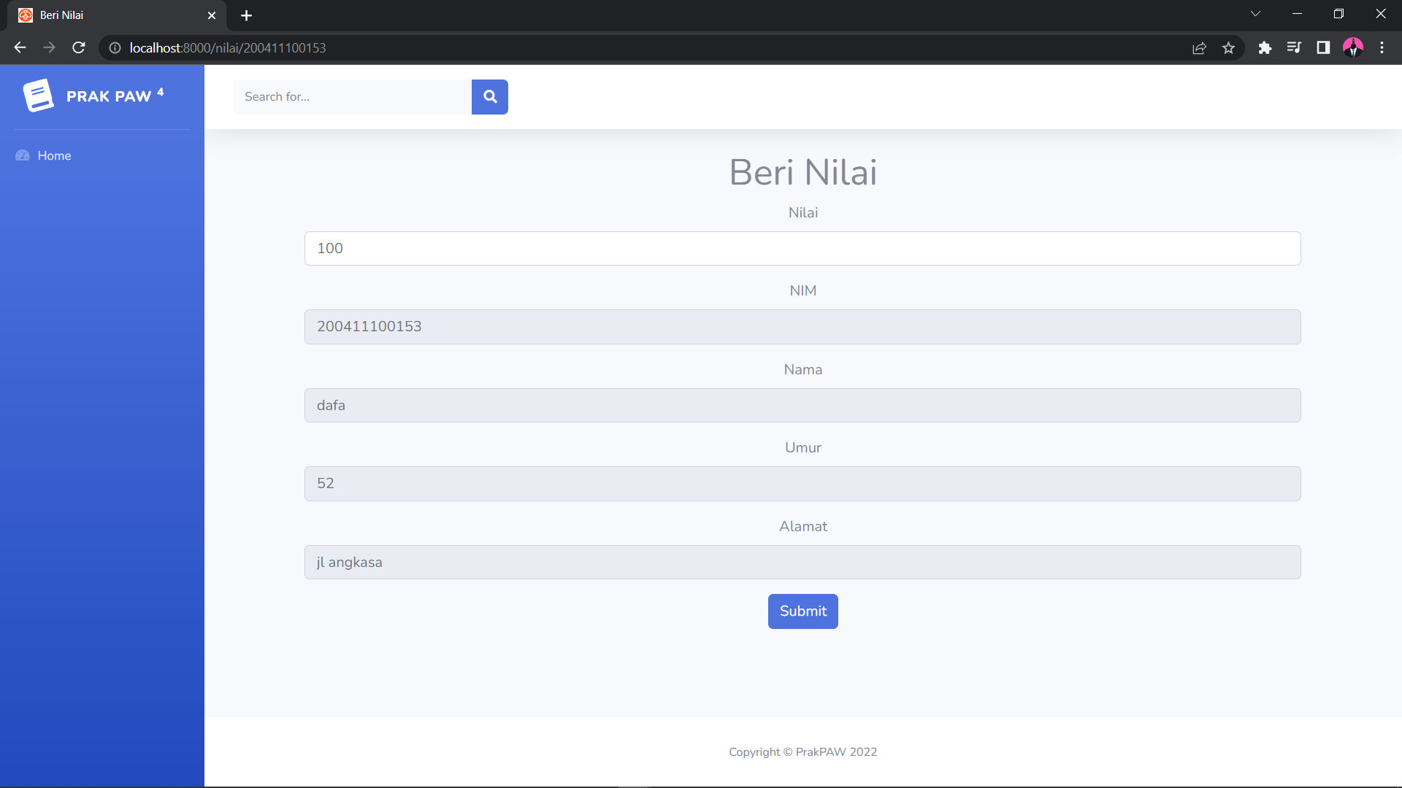

1. **SOAL :** - Menghapus Mahasiswa

**Source Code menghapus dan Controller:**

|  |
| --- |
| <?php  namespace App\Http\Controllers;  use Illuminate\Http\Request;  class ValidController extends Controller  {  public function prosestambah()  {  $mahasiswa = new \App\Models\MahasiswaModel;  $nama = request()->nama;  $nim = request()->nim;  $umur = request()->umur;  $alamat = request()->alamat;  $data = array(  'nim' => $nim,  'nama' => $nama,  'umur' => $umur,  'alamat' => $alamat  );  #cek apakah data sudah ada atau belum di database berdasarkan nim  $cek = \App\Models\MahasiswaModel::where('nim', $nim)->first();  if ($cek) {  #alert javascript dan redirect kembali ke halaman tambah  return redirect('/tambah')->with('pesan', 'Data sudah ada!');  }  $mahasiswa->create($data);  return redirect('/')->with('pesan', 'Data berhasil ditambahkan!');  }  public function nilai($id)  {  $mahasiswa = \App\Models\MahasiswaModel::find($id);  return view('pages.nilai', ['mahasiswa' => $mahasiswa]);  }  public function prosesnilai()  {  $id = request()->nim;  $mahasiswa = \App\Models\MahasiswaModel::find($id);  $mahasiswa->nilai = request()->nilai;  $mahasiswa->save();  return redirect('/')->with('pesan', 'Data berhasil diubah!');  }  public function edit($id)  {  $mahasiswa = \App\Models\MahasiswaModel::where('nim', $id)->first();  return view('pages.edit', ['mahasiswa' => $mahasiswa]);  }  public function prosesedit()  {  $nim = request()->nim;  $nimold = request()->nimold;  $nama = request()->nama;  $umur = request()->umur;  $alamat = request()->alamat;  $data = array(  'nim' => $nim,  'nama' => $nama,  'umur' => $umur,  'alamat' => $alamat  );  $mahasiswa = \App\Models\MahasiswaModel::where('nim', $nimold)->first();  if ($mahasiswa->nim != $nim) {  $cek = \App\Models\MahasiswaModel::where('nim', $nim)->first();  if ($cek) {  return redirect('/edit/' . $nimold)->with('pesan', 'Data sudah ada!');  }  $mahasiswa->update($data);  return redirect('/')->with('pesan', 'Data berhasil diubah!');  }  if ($mahasiswa->nim == $nimold && $mahasiswa->nama == $nama && $mahasiswa->umur == $umur && $mahasiswa->alamat == $alamat) {  return redirect('/edit/' . $nimold)->with('pesan', 'Data tidak berubah!');  }  $mahasiswa->update($data);  return redirect('/')->with('pesan', 'Data berhasil diubah!');  }  public function hapus($id)  {  $mahasiswa = \App\Models\MahasiswaModel::where('nim', $id)->first();  $mahasiswa->delete();  return redirect('/')->with('pesan', 'Data berhasil dihapus!');  }  public function cari()  {  $nim = request()->cari;  $mahasiswa = \App\Models\MahasiswaModel::where('nim', 'LIKE', '%' . $nim . '%')->get();  return view('pages.cari', ['mahasiswa' => $mahasiswa]);  }  } |

**SS :** 